**Assignment 1: SDLC Overview - Create a one-page infographic that outlines the SDLC phases (Requirements, Design, Implementation, Testing, Deployment), highlighting the importance of each phase and how they interconnect.**

1. **Requirements Phase :**This phase involves gathering, analyzing, and documenting the requirements for the software to be developed. It consists the need of client requirement and priorities the function that has to be implement.  
   **Importance :**It establish clear requirements and ensures alignment between client and the development team, reducing the risk of miscommunication and ensuring the final product meets user needs and introduce the MVP soon to make further changes in future.
2. **Designing Phase :**   
   One of the important aspect of SDLC as it decided the how a software product should look like. In this phase, the system architecture, design, and user interface are planned and documented based on the gathered requirements.  
   **Importance :**   
   This phase is the core part of SDLC as it’s ensures that the software is structured effectively, user-friendly, and scalable. It lays the foundation for the development process and guides implementation.
3. **Implementation Phase :**   
   Here the actual work of creating the product come into picture. During implementation, the actual code is written based on the design specifications outlined in the previous phase.  
   **Importance :** During implementation, the design is turned into working software. Attention to detail and following design principles ensure the final product functions as intended.
4. **Testing Phase :**   
   In this phase developercheck whether the functionalilty of a software woking properly or not.  
   **Importance :** Testing ensures the reliability, functionality, and quality of the software. It helps identify bugs early in the development process, minimizing risks of defects and ensuring a smooth deployment.

**Deployment Phase:**   
The final phase of the development where releasing the software to users and making it operational.  
**Importance :** Without this we won’t able to introduce our software publically for user interaction to perform various operations.

**Below digram summarize the SDLC Cycle**

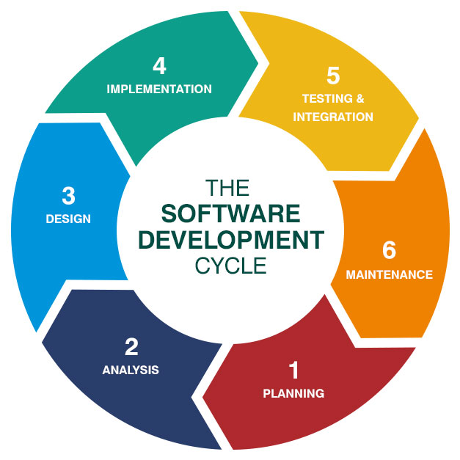

**Assignment 2: Develop a case study analyzing the implementation of SDLC phases in a real-world engineering project. Evaluate how Requirement Gathering, Design, Implementation, Testing, Deployment, and Maintenance contribute to project outcomes**.  
  
  
**Case Study :** Implementation of SDLC Phases in a Real-World Healthcare IT Project

**Project Overview** :   
HealthCare Systems , aimed at improving access to healthcare services for remote and underserved communities.

**SDLC Phases Implementation:   
1. Information Gathering:**Health Care System conducted extensive consultations with healthcare professionals, patients, and regulatory experts to understand the needs and challenges of remote healthcare delivery.

Through interviews, surveys, and focus groups, they identified requirements focusing on teleconsultation features, patient data security, and integration with existing healthcare systems.

**2. Design:**Based on the gathered requirements, design team created a comprehensive system architecture and user interface designs for the telemedicine platform.

Prototypes and wireframes were developed to visualize the user experience and refine interaction flows.

**3. Implementation:**  
The development team starts coding based on the finalized design specifications, utilizing modern web and mobile development technologies.

**4. Testing:**  
 Developer team starts functional testing, security testing, usability testing, and performance testing to ensures the reliability, functionality, and quality of the software.

User acceptance testing was conducted with healthcare providers and patients to validate the platform's usability and reliability in real-world scenarios.

**5. Deployment:**  
Following successful testing and validation, the telemedicine platform was deployed in a phased approach, starting with pilot implementations in select healthcare facilities.  
Continuous monitoring and support mechanisms were established to address any issues or concerns arising during the deployment phase.  
  
 **SDLC Contributions to Project Outcomes:**  
**Requirement Gathering:** Thorough requirement gathering ensured that the telemedicine platform addressed the unique needs of remote healthcare delivery, enhancing access to healthcare services and improving patient outcomes.

**Design:** Well-crafted design specifications led to the development of an intuitive and user-friendly telemedicine platform, facilitating adoption by healthcare providers and patients alike.

**Implementation:** Efficient implementation of the design specifications enabled Health care system to deliver a robust and scalable telemedicine platform within the project timeline, meeting the evolving needs of healthcare delivery in remote settings.

**Testing:** Continuous testing minimize the risk of software defects and security vulnerabilities, ensuring the confidentiality, integrity, and availability of patient data and healthcare services.

**Deployment:** Successful deployment enables the access to healthcare services in remote communities, contributing to improved healthcare outcomes and patient satisfaction.

**Maintenance:** Ongoing maintenance and support activities, including software updates and user training, ensured the long-term reliability and functionality of the telemedicine platform, fostering continued adoption and usage among healthcare providers and patients.

**Conclusion :**   
By following a structured approach known as the SDLC, HealthCare Systems created and launched a telemedicine platform to help people access healthcare services from remote areas. They focused on understanding what was needed, designing the platform, building it, testing to make sure it worked well, and then making it available to use. This effort resulted in an innovative, dependable solution that improved healthcare delivery and patient care.

**Assignment 3: Research and compare SDLC models suitable for engineering projects. Present findings on Waterfall, Agile, Spiral, and V-Model approaches, emphasizing their advantages, disadvantages, and applicability in different engineering contexts.**

Simple Comparison of SDLC Models for Engineering Projects

**Waterfall Model**

Advantages:

Easy to Understand: It follows a clear, step-by-step process.

Well-Documented: Each phase has specific documents and reviews.

Structured: The project is planned out in detail from the beginning.

Disadvantages:

Inflexible: Hard to make changes once you start.

Late Testing: Problems are often found late, making them expensive to fix.

Needs Clear Requirements: Assumes you know all requirements from the start.

Best For:

Projects with clear, unchanging requirements.

Small to medium projects where technology is well understood.

**Agile Model**

Advantages:

Flexible: Easy to make changes at any stage.

Customer Involvement: Regular feedback from customers ensures the product meets their needs.

Frequent Deliveries: Regular updates allow for quick improvements.

Disadvantages:

Less Predictable: Hard to predict timelines and costs.

Needs Constant Involvement: Requires ongoing customer and team interaction.

Scope Creep: Can lead to an expanding project scope due to frequent changes.

Best For:

Projects with changing requirements.

Projects needing quick and flexible development.

Complex projects that benefit from continuous feedback.

**Spiral Model**

Advantages:

Risk Management: Focuses on identifying and addressing risks early.

Iterative Development: Combines repeated development with structured planning.

Flexible: Allows for changes and improvements in each cycle.

Disadvantages:

Complex to Manage: Needs careful planning and risk management.

Costly: Can be expensive due to its thorough risk management.

Requires Oversight: Needs constant management and documentation.

Best For:

Large, complex projects with high risks.

Projects where requirements may change over time.

Critical projects where managing risk is crucial.

**V-Model (Validation and Verification Model)**

Advantages:

Clear Testing Phases: Each development phase has a corresponding testing phase.

Highly Structured: Ensures discipline and detailed documentation.

Early Error Detection: Finds defects early due to continuous testing.

Disadvantages:

Inflexible: Hard to adapt to changes once started.

Rigid: Difficult to make changes after initial planning.

Depends on Stable Requirements: Assumes requirements are well-defined from the start.

Best For:

Projects with clear, stable requirements.

Projects needing high reliability, like safety-critical systems.

Projects where thorough validation and verification are essential.

**Summary**

Each SDLC model has its own strengths and is suitable for different types of projects. The Waterfall model is good for projects with stable requirements. The Agile model is best for projects needing flexibility and quick changes. The Spiral model is great for high-risk projects with changing requirements. The V-Model is ideal for projects needing strict validation and verification.